Principal

# CERTIFICATE FROM THE INSTITUTION

This is to certify that is a student of VI Semester B COM of our college. He has prepared Internship Report entitled **“A STUDY ON UNDERSTANDING CAPITAL GAINS TAX AT APAR & CO LLP”** a study conducted during 0104-2024 to 27-04-2024 at APAR & CO LLP, as a partial fulfillment of the examination of VI Semester B COM.

**PLACE: BENGALURU**

**DATE :**

# CERTIFICATE FROM THE GUIDE

This is to certify that is a student of VI Semester B COM of our college. He has prepared Internship Report entitled **“A STUDY ON UNDERSTANDING CAPITAL GAINS TAX AT APAR & CO LLP”** under my guidance and supervision for the partial fulfillment of the requirement of the examination of VI

Semester B COM.

**PLACE: BENGALURU**

**DATE:**

## TABLE OF CONTENT

|  |  |  |  |
| --- | --- | --- | --- |
| **Sl.no** | **Contents** | **Page no** | |
|  | Chapter 1 |  | |
| 1.1 | Introductions | 1 | |
| 1.2 | Capital Gains | 2 | |
| 1.3 | History of Capital Gains Taxation in India | 2 | |
| 1.4 | The Evolution of Capital Gains Taxation in India | 4 | |
| 1.5 | Legislative Measures to Improve Capital Gains Taxation | 4 | |
| 1.6 | Scope and Year of Chargeability | 6 | |
| 1.7 | Capital Asset | 7 | |
| 1.8 | Types of Transfer in relation to Capital Asset | 8 | |
| 1.9 | Cost of improvement [Section 55] | 9 | |
| 1.10 | Cost of Acquisition [Section 55] | 10 | |
| 1.11 | Advantages of Capital Gains | 12 | |
| 1.12 | Tax Advantages of Capital Gains | 14 | |
| 1.13 | Advantages of Capital Loss Carryforward | 15 | |
| 1.14 | Benefits of Long-Term Capital Gains Treatment | 17 | |
| 1.15 | Advantages of Short-Term Capital Gains Treatment | 18 | |
| 1.16 | Capital Gains Tax Strategies | 19 | |
| 1.17 | The maximum capital gains tax rate for individuals and corporations from past to present | 21 | |
| 1.18 | Company profile | 22 | |
| 1.19 | Services provided by the firm | 23 | |
|  | Chapter 2 |  | |
| 2.1 | Introduction | 24 | |
| 2.2 | Objective of the study | 24 | |
| 2.3 | Methodology adopted. | 24 | |
| 2.4 | Scope of the study | 24 | |
| 2.5 | Limitation of the study | 25 | |
|  | Chapter 3 |  | |
| 3.1 | Introduction | 26 | |
| 3.2 | Short-term Capital Asset | 26 | |
| 3.3 | Short-term capital gains under Section 111A | | 26 |
| 3.4 | Format of short-term capital gain | | 27 |
| 3.5 | Long-term Capital Asset | | 27 |
| 3.6 | Long-term capital gains under section 112/112A | | 27 |
| 3.7 | Format of long-term capital gain | | 28 |
| 3.8 | Tax Rate on Long-Term Capital Gain and Short-Term  Capital Gain | | 29 |
| 3.9 | Deduction of Expenses Allowed from the Final Value of Consideration | | 31 |
| 3.10 | Exemptions on capital gain tax | | 32 |
| 3.11 | Points to consider while computing capital gains | | 33 |
| 3.12 | The CII for different years is determined by the Central Government | | 35 |
| 3.13 | Computation of capital gains | | 37 |
|  | Chapter 4 | |  |
| 4.1 | Learning outcomes of the internship | | 43 |
| 4.2 | Findings | | 44 |
| 4.3 | Conclusion | | 44 |
|  | Bibliography | |  |
|  | Annexure | |  |

**CHAPTER 1**

**INTRODUCTION**

**AND COMPANY**

**PROFILE**

**1.1 Introduction**

A capital gains tax (CGT) is the tax on applicable realized on the sale of a noninventory asset. The most common capital gains are realized from the sale of stocks, bonds, precious metals, real estate, and property. Capital gains taxes are payable on the most valuable items or assets sold at a profit. Antiques, shares, precious metals and second homes could all be subject to the tax if the profit is large enough. This lower boundary of profit is set by the government. If the profit is lower than this limit it is tax-free. The profit is in most cases the difference between the amount an asset is sold for and the amount it was bought for.

The profit you earn from selling these assets is known as "Capital Gain," and it is considered taxable income. The capital gain is calculated based on the difference between the Purchase Price of the asset and the Selling Price. The tax you pay from this income is referred to as Capital Gains Tax or CGT. This tax is charged under the head of capital gains for the sale made in the previous year.

You are liable to pay the capital gain tax when:

* You have sold an asset that comes under the category of a capital asset.
* You have profited from the sale.
* The sale is made in the previous year (the year immediately before the assessment year)

Ideally, a capital gain tax is levied on any person or firm that decides to sell an asset for profit. The only exception is for day traders, who engage in the buying and selling of assets to make a living. As for the day traders, the profits they make are taxed based on their business revenue rather than capital gains. It’s also important to note that capital gain taxes are levied on different types of assets, whether they are stocks, bonds, or real estate property.

Almost everything you own and use for personal, or investment purposes is a capital asset. Examples of capital assets include a home, personal-use items like household furnishings, and stocks or bonds held as investments. You have a capital gain if you sell the asset for more than your adjusted basis. You have a capital loss if you sell the assets for less than your adjusted basis. Losses from the sale of personal-use property, such as your home or car, aren't tax deductible. Capital gains taxes play a significant role in shaping investment decisions and financial planning in India. Capital gains refer to the profits earned from the sale of capital assets, such as real estate, stocks, mutual funds, and other investments. In India, these gains are categorized into short-term and long-term gains, each attracting different tax rate.

## 1.2 Capital Gains

Section 45 of Income Tax Act, 1961 provides that any profits or gains arising from the transfer of a capital asset effected in the previous year will be chargeable to income-tax under the head ‘Capital Gains’. Such capital gains will be deemed to be the income of the previous year in which the transfer took place. In this charging section, two terms are important. One is “capital asset” and the other is “transfer”.

## 1.3 History of Capital Gains Taxation in India

The history of capital gains taxation goes back to the Budget of 1947 when capital gains tax was introduced by inserting section 12B in the Indian Income-tax Act, 1922 with effect from AY 1947-48 to curb the speculative activity of buying and selling assets in an inflationary environment in the wake of World War II. However, it was abolished after two years as it was hampering the growth of the stock market.

On the recommendation of Prof. Nicholas Kaldor, based on the principle of equity in taxation and with a view to augmenting tax revenue, capital gains tax was reintroduced by the Finance Act of 1956 in respect of sale, exchange, relinquishment, or transfer of capital asset effected after 31-03-1956. Since then, levy of tax on capital gains became a permanent feature of the Indian tax structure. During the period of last over six decades, India has come a long way in the field of capital gains taxation.

In the post-Independence era, the Union Budget of 1956–1957 made the levy of capital gains tax permanent in India. The then finance minister Tiruvellore Thattai Krishnamachari introduced a capital gains tax regime where capital gains up to Rs 15,000 were exempt from taxation while individuals with gains of more than Rs 10 lakh were taxed at 31.3 per cent.

Under the leadership of the then finance minister, Manmohan Singh, introduced indexation benefits for capital gains and a special tax rate of 20 per cent for long term capital gain. Since then, for the long-term capital gain, the cost of acquisition and the cost of improvement of assets are linked to a cost inflation index that is notified by the government every year. Indexation is the process by which the cost of inflation is adjusted against the inflationary rise in the value of an asset. During this era, there were discussions about the exemption of dividend tax for shareholders, but it was not accepted.

In 1997, the then finance minister, P Chidambaram, continued the 20 per cent tax for long term capital gains with indexation and exempted dividend tax for the shareholders. Then in 1999 the finance minister, Yashwant Sinha, capped the tax on long term capital gains at 10 per cent for stocks. Thus, a taxpayer was given the choice of being taxed on long term capital gains on assets at 20 percent with indexation or at 10 percent without benefit.

In 2003 the idea of not levying the long-term capital gain tax was one of the recommendations of the Vijay Kelkar-led task force on direct taxes in 2002. In 2003–04, the finance minister, Jaswant Singh, removed such a tax in a limited way, with the intention of reviewing the change the following year. However, during his tenure, proposals for a 20 percent tax with indexation or a 10 percent tax without indexation were continued, while short-term capital gains were taxed as per the slab rate.

In 2004 the finance minister, P Chidambaram, for the long-term capital gains (LTCG) from securities transactions altogether he proposed to levy a small tax on transactions in securities on stock exchanges. He also introduced taxation for short-term capital gains at 10 per cent, which was eventually increased to 15 per cent in the 2008 Budget.

In Budget 2018, the finance minister, Arun Jaitley, proposed to impose long term capital gain tax on equities exceeding Rs 1, 00,000 at 10 per cent, while he also introduced a 10 per cent dividend tax for dividends greater than Rs 10,00,000 per annum.

In 2020, Finance Minister Nirmala Sitharaman in her Budget speech on February 1 announced the abolition of the dividend distribution tax. She made dividends taxable in the hands of shareholders.

## 1.4 The Evolution of Capital Gains Taxation in India

The capital gains taxation of listed securities has undergone significant changes over the past three decades, from the levy of a special tax rate of 20% on LongTerm Capital Gains (LTCG) after indexation in 1992 to the grant of exemption on LTCG earned from listed securities in 2004 [subject to levy of a nominal Securities Transaction Tax (STT)] and the reintroduction of LTCG tax on equities by the Finance Act, 2018. These changes have paved the way for increased investor participation in the stock market and, as a result, the deepening of the equity markets in India. Capital gains taxation has, for the most part, always changed throughout history. The evolution of capital gains taxation has primarily taken two forms:

1. By rationalizing and streamlining the statutory provisions to close gaps and plug loopholes.
2. By relieving the genuine hardship of taxpayers by occasionally loosening the strict application of the law.

Due to all of this, capital gains taxation in India has been able to adapt to the needs of a rapidly developing economy and to the changing times. In addition, capital gains taxation has proven to be a useful instrument for promoting economic development and growth by encouraging the allocation of capital gains towards high-priority economic sectors such as infrastructure, housing, agriculture, small and medium-sized businesses (SMEs), and rural electrification.

## 1.5 Legislative Measures to Improve Capital Gains Taxation

The Legislature has been taking necessary steps from time to time for removing the gaps and sealing the loopholes in existing provisions and thereby suppressing the potential damage by bringing in appropriate corrective measures to check tax evasion. For instance, Section 48 was replaced by the Finance Act, 1992 with effect from AY 1993–94 and forward, granting the benefit of indexation of cost of acquisition and cost of improvement on transfer of long-term capital assets, to counteract the effect of price inflation over the period during which LTCG had arisen. This was done in response to recommendations made by the Chelliah Committee to rationalize the system of LTCG taxation. Some of the crucial measures were taken and as follows:

* Section 50C was added to the law book with effect from AY 2003–04 to prevent widespread tax fraud through understating the consideration received for the sale of real estate at the time of transfer.
* Section 55 of subsection (1) and (2) were recently amended by the Finance Act, 2023 to state that the costs of acquisition and improvement of any intangible asset or other from those already mentioned in section 55(1)(b)(1) and section 55(2)(a) of a capital asset shall be assumed to be nil.
* The legislature has also taken several actions to try to remove obstacles and lessen the actual suffering that the strict provisions of the Act have caused to the taxpayers. Several notable instances in this context include the addition of a new section 45(5) to the Finance Act, 1987, effective from January 04, 1988, which allows for the taxation of both initial and additional compensation in the year of receipt rather than the year of capital asset transfer through compulsory acquisition due to the significant time delay between the date of transfer and the date of compensation payment.
* The Finance Act, 1991, with effect from. 01-10-1991, inserted a new section 54H, which states that the period for depositing or investing the capital gain in acquiring the new asset under sections 54, 54B, 54D, 54EC, and 54F shall be determined from the date of receipt of such compensation. The third proviso to section 50C (1) prescribes an exception limit of 5% as of 01-04-2019 and 10% as of 01-04-2021 to avoid the substitution of stamp duty value for the declared sale consideration. Experts and observers on tax policy have long discontent and been hopeless about the complexity of direct tax legislation in India.

## 1.6 Scope and Year of Chargeability

* **Receipts from insurance parties [Section 45(1A)]:**

Where any person receives any money or other assets under any insurance from an insurer, then, any profits or gains arising from receipt of such money or other assets shall be treated as “Capital gains” and shall be deemed to be the income of such person in the year of receipt.

* **Conversion or treatment of a capital asset as stock-in-trade [Section 45(2)]:**

The profits or gains arising from such conversion or treatment will be chargeable to income tax as his income of the previous year in which such stock-in-trade is sold or otherwise transferred by him.

* **Transfer of beneficial interest in securities [Section 45(2A)]:**

Where any person has had at any time during the previous year any beneficial interest in any securities, then, any profits or gains arising from the transfer made by the Depository or participant of such beneficial interest in respect of securities shall be chargeable to tax as the income of the beneficial owner of the previous year in which such transfer took place and shall not be regarded as income of the depository who is deemed to be the registered owner of the securities by virtue of section 10(1) of the Depositories Act, 1996.

* **Introduction of capital asset as capital contribution [Section 45(3)]:**

With the transfer of a capital asset to a firm, Association of Persons, or Body of Individuals as capital contribution or otherwise, the profits or gains arising from such transfer will be chargeable to tax as income of the previous year in which such transfer takes place.

* **Distribution of capital assets on a firm’s dissolution [Section 45(4)]:**

The transfer of capital assets by way of distribution of capital assets on the dissolution of a firm or AOP or BOI or otherwise shall be chargeable to tax as the income of the firm etc. of the previous year in which such transfer takes place. For this purpose, the fair market value of the asset on the date of such transfer shall be the full value of consideration.

* **Compensation for compulsory acquisition [Section 45(5)]:**

When the Central Government pays compensation for compulsory acquisition of a building or some other capital asset belonging to a person, capital gains may rise. Such gains are chargeable as income of the previous year in which such compensation is received.

## 1.7 Capital Asset

Capital assets are tangible and illiquid property which a business intends to use to generate revenue and expects its usefulness to exceed one year.

According to section 2(14), a capital asset means –

1. property of any kind held by an assessee, whether connected with his business or profession.
2. any securities held by a Foreign Institutional Investor which has invested in such securities in accordance with the SEBI regulations.

However, it does not include –

Any stock-in-trade [other than securities referred to in (b) above], consumable stores or raw materials held for the purpose of the business or profession of the assessee.

1. Personal effects movable property (including wearing apparel and furniture) held for personal use by the assessee or any member of his family dependent on him, but excludes –
   * Jewellery.
   * Archaeological collections.
   * Drawings.
   * Paintings,
   * Sculptures or any work of art.

1. Rural agricultural land in India
2. 6½% Gold Bonds, 1977, or 7% Gold Bonds, 1980, or National Defence Gold Bonds, 1980, issued by the Central Government.
3. Special Bearer Bonds, 1991 issued by the Central Government.
4. Gold Deposit Bonds issued under the Gold Deposit Scheme, 1999 notified by the Central Government.

Rural Agricultural Land shall mean: -

Only rural agricultural lands in India are excluded from the purview of the term

‘capital asset.’ Hence urban agricultural lands constitute capital assets. Transfer of agricultural land situated in any area within the authority of a municipality or cantonment board having a population of 10000 or more shall be chargeable to “Capital Gains” including the following limits: -

* Aerial distance from the local limits of a municipality or cantonment board ≤ 2 kilometres & corresponding population is > 10,000 ≤ 1,00,000.
* Aerial distance from the local limits of a municipality or cantonment board ≤ 6 kilometres & corresponding population is > 1,00,000 ≤ 10,00,000.
* Aerial distance from the local limits of a municipality or cantonment board ≤ 8 kilometres & corresponding population is > 10,00,000.

## 1.8 Types of Transfer in relation to Capital Asset

Section 2(47) provides an inclusive definition of “transfer”, in relation to a capital asset.

* The sale, exchange, or relinquishment of the asset; or
* The extinguishment of any rights therein; or
* The compulsory acquisition thereof under any law; or
* The owner of a capital asset may convert the same into the stock-in-trade of a business carried on by him. Such conversion is treated as a transfer; or
* The maturity or redemption of a Zero-Coupon Bond; or
* Part-performance of the contract: Sometimes, possession of the immovable property is given in consideration of part-performance of a contract; or
* Lastly, there are certain types of transactions that have the effect of transferring or enabling the enjoyment of the immovable property. Even the power of attorney transactions is covered.

Section 2(47) clarifies that ‘transfer’ includes and shall be deemed to have always included:

* Disposing of or parting with an asset or any interest therein, or
* Creating any interest in any asset in any manner, directly or indirectly, absolutely, or conditionally, voluntarily, or involuntarily by way of an agreement (whether entered in India or outside India) or otherwise.

## 1.9 Cost of improvement [Section 55]

The cost of improvement is the capital expenditure incurred by an assessee for making any addition or improvement in the capital asset. It also includes any expenditure incurred in protecting or curing the title.

1. Goodwill of a business, etc. In relation to a capital asset being the goodwill of a business or a right to manufacture, produce or process any article or thing, or right to carry on any business, the cost of the improvement shall be taken to be Nil.
2. Any other capital asset:
   * Where the capital asset became the property of the previous owner or the assessee before 1-4-2001, the cost of improvement means all expenditure of a capital nature incurred in making any addition or alteration to the capital asset on or after the said date by the previous owner or the assessee.
   * In any other case, the cost of improvement means all expenditure of a capital nature incurred in making any additions or alterations to the capital assets by the assessee after it became his property. However, there are cases where the capital asset might become the property of the assessee by any of the modes specified in section 49(1). In that case, the cost of improvement means capital expenditure in making any addition or alterations to the capital assets incurred by the previous owner.

However, cost of improvement does not include any expenditure which is deductible in computing the income chargeable under the head “Income from house property”, “Profits and gains of business or profession” or “Income from other sources”.

## 1.10 Cost of Acquisition [Section 55]

Acquisition Cost (AC) is the total amount of money (all-in cost) a company or a business spends on acquiring assets, getting new clients, or overtaking a new company. It is also referred to as the cost of acquisition and most companies and investors refer to it as a key business metric.

1. Goodwill of a business or a trademark or brand name associated with a business or a right to manufacture, produce or process any article or thing, or right to carry on any business, tenancy rights, stage carriage permits and loom hours - In the case of the above capital assets, if the assessee has purchased them from a previous owner, the cost of acquisition means the amount of the purchase price. For example, if A purchases a stage carriage permit from B for 2 lakhs, that will be the cost of acquisition for A.
2. Self-generated assets - There are circumstances where it is not possible to visualize the cost of acquisition. For example, suppose a doctor starts his profession. Over time, the doctor acquires a lot of reputation. He opens a clinic and runs it for 5 years. After 5 years he sells the clinic to another doctor for ₹ 10 lakh which includes ₹ 2 lakh for his reputation or goodwill. Now a question arises as to how to find out the profit in respect of goodwill. It is obvious that goodwill is self-generated and hence it is difficult to calculate the cost of its acquisition. However, it is certainly a capital asset.
3. Other assets - In the following cases, the cost of acquisition shall not be nil, but will be deemed to be the cost for which the previous owner of the property acquired it:

Where the capital asset became the property of the assessee—

* + On any distribution of assets on the total or partial partition of a Hindu undivided family.
  + Under a gift or will.
  + By succession, inheritance, or devolution.
  + On any distribution of assets on the liquidation of a company.
  + Under a transfer to a revocable or an irrevocable trust.
  + Under any such transfer referred to in sections 47(iv), (v), (vi), (via) or (viaa).
  + Where the assessee is a Hindu undivided family, by the mode referred to in section 64(2).

1. Financial assets - Many times persons who own shares or other securities become entitled to subscribe to any additional shares or securities. Further, they are also allotted additional shares or securities without any payment. Such shares or securities are referred to as financial assets in the Income-tax Act. Section 55 provides the basis for ascertaining the cost of acquisition of such financial assets.
2. Any other capital asset –
   * Where the capital asset became the property of the assessee before 1-42001 the cost of the asset to the assessee or the fair market value of the asset on 1-4-2001 at the option of the assessee.
   * Where the capital asset became the property of the assessee by any of the modes specified in section 49(1), the cost of acquisition to the assessee will be the cost of acquisition to the previous owner. Even in such cases, where the capital asset became the property of the previous owner before 1-4-2001, the assessee has got a right to decide on the fair market value as on 1-4-2001.
   * Where the capital asset became the property of the assessee on the distribution of the capital assets of a company on its liquidation and the assessee has been assessed to capital gains in respect of that asset under section 46, the cost of acquisition means the fair market value of the asset on the date of distribution.
   * A share or a stock of a company may become the property of an assessee under the following circumstances:
     1. The consolidation and division of all or any of the share capital of the company into shares of larger amount than its existing shares.
     2. The conversion of any shares of the company into stock,
     3. The re-conversion of any stock of the company into shares,
     4. The sub-division of any of the shares of the company into shares of smaller amount, or
     5. The conversion of one kind of shares of the company into another kind.

In the above circumstances, the cost of acquisition to the assessee will mean the cost of acquisition of the asset calculated with reference to the cost of acquisition of the shares or stock from which such asset is derived.

1. Where the cost for which the previous owner acquired the property cannot be ascertained, the cost of acquisition to the previous owner means the fair market value on the date on which the capital asset became the property of the previous owner.

## 1.11 Advantages of Capital Gains

Capital gains are the profits that an investor earns when they sell an asset, such as stocks, real estate, or mutual funds, for a higher price than what they initially paid for it. Capital gains are an important aspect of investing as they provide investors with the opportunity to make a profit from their investments. While capital gains can be taxed, they can also offer a range of benefits to investors.

* **Tax Benefits:** One of the most significant benefits of capital gains is that they are taxed at a lower rate than regular income. The current tax rate for longterm capital gains (assets held for more than a year) is 0%, 15%, or 20%, depending on an investor's income. In contrast, regular income tax rates can range from 10% to 37%, depending on an investor's income level. This lower tax rate on capital gains can result in significant tax savings for investors.
* **Diversification:** Capital gains can also provide investors with the opportunity to diversify their investment portfolio. By investing in different assets, an investor can spread their risk and potentially increase their returns. For example, an investor who owns stocks in a variety of industries, such as healthcare, technology, and finance, is less likely to be impacted by a downturn in any one industry.
* **Compound Interest:** Another advantage of capital gains is the potential for compound interest. When an investor earns a profit on an investment, they can reinvest that profit to earn even more profits in the future. For example, if an investor earns a capital gain of $1,000 on a stock investment, they can reinvest that $1,000 to potentially earn additional capital gains in the future.
* **Estate Planning:** Capital gains can also be important for estate planning. When an investor passes away, their assets are typically transferred to their heirs. If those assets have appreciated in value, the heirs will be responsible for paying capital gains tax on the difference between the original purchase price and the sale price. However, if the investor passes away before selling the asset, the heirs will receive a step-up in basis, which means that the cost basis of the asset is increased to the current market value. This can result in significant tax savings for the heirs.

Capital gains offer several advantages to investors, including tax benefits, diversification, compound interest, and estate planning benefits. While there are risks associated with investing, capital gains can be an effective way to grow wealth over time.

## 1.12 Tax Advantages of Capital Gains

When it comes to securing our financial future, one of the key strategies we can employ is investing in assets that generate capital gains. Capital gains are the profits earned from the sale of an asset, such as stocks, real estate, or precious metals. Not only do capital gains provide a way to grow our wealth over the long term, but they also offer significant tax advantages that can further enhance our financial position. In this section, we will explore the various tax benefits associated with capital gains, considering different perspectives, and providing indepth information to help you make informed decisions about your investments.

* **Lower Tax Rates:** One of the most significant advantages of capital gains is the preferential tax rates they attract. Unlike ordinary income, which is taxed at higher rates, capital gains are subject to special tax rates. For example, longterm capital gains (assets held for more than one year) are taxed at a maximum rate of 20% for high-income earners. This is substantially lower than the top marginal tax rate of 37% applicable to ordinary income. This lower tax rate can result in substantial tax savings, allowing investors to retain a larger portion of their profits.
* **Tax Deferral:** Another noteworthy advantage of capital gains is the ability to defer taxes until the asset is sold. This means that if you hold onto your investment, you can delay paying taxes on the gains, potentially allowing for further growth and compounding of your investment. For instance, if you invest in stocks and the value appreciates significantly over time, you can defer paying taxes on the gains until you decide to sell the shares. This deferral of taxes can be particularly advantageous for long-term investors looking to maximize their returns.
* **Step-up in Basis:** In the case of inherited assets, capital gains tax can be further mitigated through a step-up in basis. When an individual acquires an asset, such as real estate or stocks, the cost of the asset is reset to its fair market value at the time of inheritance. This means that any appreciation in the value of the asset up until the date of inheritance is effectively exempt from capital gains tax.
* **Capital Loss Deductions:** While capital gains are subject to favorable tax treatment, it is important to note that capital losses can also be utilized to offset capital gains. If you sell an asset at a loss, you can deduct the loss against any capital gains you have realized in the same tax year. If the capital losses exceed the capital gains, you can carry forward the losses up to 8 assessment years from the assessment year in which the loss was incurred.
* **tax-Advantaged accounts:** While capital gains offer inherent tax advantages, using tax-advantaged accounts can further enhance these benefits. Retirement accounts such as a 401(k) or an individual Retirement account (IRA) provide a tax-advantaged environment for investments. Contributions to these accounts are made with pre-tax dollars, allowing for tax-free growth of investments until withdrawal during retirement. By investing in assets that generate capital gains within these accounts, individuals can potentially enjoy tax-free or taxdeferred growth, maximizing their long-term returns.

Capital gains are not only a way to increase our wealth, but also provide significant tax advantages that can impact our financial future, whether it is positive or negative. From lower tax rates and tax deferral to step-up in basis and capital loss deductions, there are various strategies to optimize the tax benefits associated with capital gains. Additionally, using tax-advantaged accounts can further enhance these advantages. It is important to consult with a financial advisor or tax professional to find the best options for your specific financial goals and circumstances.

## 1.13 Advantages of Capital Loss Carryforward

Capital Loss Carryforward is a tax strategy that allows individuals or businesses to use their capital losses to offset their capital gains in future tax years. This strategy is particularly useful for those who have experienced losses in their investment portfolios or businesses. By using this strategy, individuals or businesses can reduce their taxable income, thus reducing their tax liability. In this section, we will discuss the advantages of Capital Loss Carryforward and how it can help individuals and businesses.

* **Reduces Tax Liability:** The most significant advantage of Capital Loss Carryforward is that it helps to reduce tax liability. When individuals or businesses have capital losses, they can use those losses to offset any capital gains they may have in the future. This reduces their taxable income, and as a result, they pay less in taxes.
* **Provides Flexibility:** Capital Loss Carryforward provides flexibility to individuals and businesses. They can carry forward their capital losses for up to seven years and use them to offset any capital gains they may have in the future. This means that individuals and businesses do not have to use their capital losses at once, and they can choose when to use them based on their financial situation.
* **Provides a Safety Net:** Capital Loss Carryforward provides a safety net for individuals and businesses who experience losses in their investments or businesses. By being able to carry forward their losses, they can offset any future gains and reduce their tax liability. This can help to mitigate the impact of any losses and provide a safety net for individuals and businesses.
* **Carryovers of capital losses might be helpful when planning your investment strategy:** You can reduce the total tax impact of your investing activities if you experience sizable capital losses in a single asset class or investment by offsetting those losses against capital gains from other investments. For this reason, you may be more inclined to invest in riskier investments knowing there are potential tax advantages that may help you offset high gains in other areas.

Capital Loss Carryforward is a valuable tax strategy that can help individuals and businesses in several ways. By reducing tax liability, providing flexibility, helping to build wealth, and providing a safety net, Capital Loss Carryforward can help individuals and businesses achieve their financial goals. It is important to consult with a tax professional to figure out the best strategy for using Capital Loss Carryforward based on individual circumstances.

## 1.14 Benefits of Long-Term Capital Gains Treatment

* Tax Rate Advantage: One of the key benefits of long-term capital gains treatment is the potential for lower tax rates compared to short-term gains. Under the current tax laws in many countries, long-term capital gains are typically taxed at a lower rate than ordinary income or short-term capital gains.
* **Increased Flexibility and Strategic Planning:** Long-term capital gains treatment provides investors with greater flexibility in managing their investments. By holding on to an investment for the long term, investors can strategically time the sale of their assets to minimize tax liabilities and maximize returns. This flexibility allows investors to align their investment decisions with their overall financial goals and market conditions.
* **Compounding Effect:** Long-term capital gains treatment can enhance the power of compounding, which is a fundamental principle in investing. By allowing investments to grow over an extended period, investors can benefit from the compounding effect, where the returns generated on the initial investment are reinvested and generate additional returns. The longer the investment is held, the greater the potential for compounding to work its magic.
* **Estate planning and Wealth transfer:** Long-term capital gains treatment can also play a crucial role in estate planning and wealth transfer strategies. When assets are held for an extended period, their value may appreciate significantly, resulting in potential capital gains. By taking advantage of the long-term capital gains treatment, investors can minimize the tax burden on their heirs when transferring wealth.
* **The Best Option:** While long-term capital gains treatment offers various advantages, it is essential to consider individual circumstances and investment goals when deciding between long-term and short-term capital gains treatment. Short-term gains may be more suitable for investors who prefer shorter investment horizons and need access to immediate liquidity. On the other hand, long-term gains are generally more advantageous for investors with a long-term investment horizon who prioritize tax efficiency, flexibility, and the power of compounding. Therefore, the best option ultimately depends on an investor's specific needs, risk tolerance, and financial objectives.

The benefits of long-term capital gains treatment let you to know about its advantages in terms of tax rate, flexibility, compounding effect, and estate planning. While short-term gains may be suitable for some investors, long-term capital gains treatment offers numerous advantages that can contribute to longterm financial success. By understanding the benefits and considering individual circumstances, investors can make informed decisions about the most suitable path to choose when it comes to capital gains treatment.

## 1.15 Advantages of Short-Term Capital Gains Treatment

When it comes to investing, understanding the differences between long-term and short-term capital gains treatment is crucial. While long-term gains are taxed at a lower rate, short-term gains are subject to ordinary income tax rates.

* **Immediate access to profits:** One of the primary advantages of short-term capital gains treatment is the ability to access your profits immediately. Unlike long-term investments, which require holding assets for at least one-year, short-term investments allow for quicker turnaround. This can be particularly beneficial for investors who are seeking to capitalize on short-term market trends or take advantage of shorter-term investment opportunities.
* **Flexibility in investment strategy:** Short-term capital gains treatment provides investors with greater flexibility in their investment strategy. Because short-term investments have a shorter holding period, investors can adapt their portfolio to changing market conditions more often. This flexibility allows for a more active approach to investing, where investors can take advantage of market volatility and adjust accordingly.
* **Tax-loss harvesting opportunities:** Short-term capital gains treatment can also be beneficial when it comes to tax-loss harvesting. Tax-loss harvesting involves selling investments at a loss to offset capital gains and potentially lower your overall tax liability. Since short-term gains are taxed as ordinary income rates, the ability to offset these gains with short-term losses can result in significant tax savings.
* **The benefit of short-term capital gains treatment:** It has the potential for higher deductions for investment expenses. While investment expenses are normally deductible for both short-term and long-term investments, short-term gains are subject to ordinary income tax rates, which can result in higher deductions. This can be particularly beneficial for investors who actively trade or have significant investment-related expenses.

While short-term capital gains treatment offers several advantages, it is important to consider your individual circumstances and investment objectives. For some investors, the potential for higher taxes on short-term gains may outweigh the benefits. It is always recommended to consult with a tax professional or financial advisor to figure out the best approach for your specific situation.

## 1.16 Capital Gains Tax Strategies

Individuals can take a variety of steps to reduce or offset capital gains. “Once again, it’s important to look at capital gains from a broader financial strategy perspective,” says Willing. “In some situations, it can even make sense to harvest gains now when there are opportunities to offset those gains with losses.”

* **Tax loss harvesting:** No one likes to sell investments at a loss. However, there can be tax benefits to selling investments in a down market. The holding period is once again crucial. First, long-term capital gains need to be netted with long-term capital losses, and the same with short-term gains and losses. Then, the total net long-term capital gain or losses is netted with the total net short-term gain or loss. If you have a loss that is greater than your gains at the end of all this netting, then you can carry that loss forward to use in future years.
* **Donate appreciated assets to charity:** Rather than making a cash donation to a charity or donor advised fund, consider donating appreciated stock. The net amount is the same, but you won’t have to pay capital gains tax or Net investment income tax on the appreciated value of the stock, and qualifying tax-exempt charities are not taxed on gains when they sell that stock.
* **Create a tax-diversified investment portfolio:** Consider adding investments that are more tax friendly like municipal bonds issued in the state where you live typically generate income that is exempt from both federal and state income taxes. Treasury bonds are also exempt from state taxes. The returns tend to be lower than corporate bonds, but they create a tax-free income stream. Some insurance products, such as variable index products, are also advantageous from a tax perspective.
* **Invest for the long term:** If you manage to find great companies and hold their stock for the long term, you will pay the lowest capital gains tax rate. Of course, that is not easy. A company’s fortunes can change over the years, and there are many reasons why you might want or need to sell earlier than you originally anticipated.
* **Take advantage of tax-deferred retirement plans:** When you invest your money through a retirement plan, such as a [401(k),](https://www.investopedia.com/terms/1/401kplan.asp) [403(b),](https://www.investopedia.com/terms/1/403bplan.asp) or [individual retirement account (IRA)I](https://www.investopedia.com/terms/i/ira.asp)t will not be subject to immediate taxes. You can also buy and sell investments within your retirement account without triggering capital gains tax.
* **Watch your holding periods**: An asset must be sold more than a year to the day after it was purchased for the sale to qualify to be treated as a long-term capital gain. Waiting a few days or weeks to qualify for long-term capital gains treatment might be a wise move if the investment's price is holding relatively steady.
* **Cash in After Retiring:** As you approach retirement, consider waiting until you stop working to sell profitable assets. The capital gains tax bill might be reduced if your retirement income is lower. You may even be able to avoid having to pay capital gains tax at all. In short, be mindful of the impact of taking the tax hit when working rather than after you're retired. Realizing the gain earlier might serve to bump you out of a low- or no-pay bracket and cause you to incur a tax bill on the gains.

**1.17 The maximum capital gains tax rate for individuals and corporations from past to present:**

|  |  |  |
| --- | --- | --- |
| Year | Individual capital gains tax rate | Corporate capital gains tax rate |
| 1913–1921 | same as regular rate | same as regular rate |
| 1922–1933 | 12.5% | 12.5% |
| 1934–1935 | 17.7%* | 13.75% |
| 1936–1937 | 22.5%* | 15.0% |
| 1938–1941 | 15.0% | same as regular rate |
| 1942–1951 | 25.0% | 25.0% |
| 1952–1953 | 26.0% | 26.0% |
| 1954 | 25.0% | 26.0% |
| 1955–1967 | 25.0% | 25.0% |
| 1968 | 26.9% | 25.0% |
| 1969 | 27.5% | 25.0% |
| 1970 | 30.2% | 25.0% |
| 1971 | 32.5% | 25.0% |
| 1972–1974 | 35.0% | 25.0% |
| 1975–1977 | 35.0% | 30.0% |
| 1978 | 33.8% | 30.0% |
| 1979 | 35.0% | 30.0% |
| 1980–1981 (June 9) | 28.0% | 28.0% |
| 1981 (after June 9)–1986 | 20.0% | 28.0% |
| 1987–1992 | 28.0% | 34.0% |
| 1993–1997 (May 6) | 28.0% | 35.0% |
| 1997 (after May 6)–2003  (May 5) | 20.0% | 35.0% |
| 2003 (after May 5)–2012 | 15.0% | 35.0% |
| 2013–2017 | 20.0% | 35.0% |
| 2018-2023 | 20.0% | 21.0% |

*Assumes 10-year holding period, 30% of gain recognized (sliding scale for exclusion based on holding period).

## 1.18 Company profile



|  |  |
| --- | --- |
| Name of the firm | APAR & CO LLP |
| Name of the Partner | MR. Amruth Lal R Patel and MR. Ashwin Patel |
| Address | 1ST FLOOR,15TH CROSS, 100 FEET RING ROAD, SARAKKI SIGNAL, JP NAGAR 1st  PHASE, BANGALORE 560078 |
| EMAIL | amruth@caapar.com |
| CIN/LLPIN/FCRN | AAS-8336 |
| ROC Code | Roc-Bangalore |
| Business Activity Code of APAR & Co LLP | 74 |
| Company Classification | Limited Liability Partnership |

APAR & CO LLP (Limited Liability partnership firm) is a chartered Accountant firm. It is rendering comprehensive professional services which include Audit management consultancy, Tax consultancy, accounting services.

A P A R & Co LLP (APARCL) is 3 years 8 months old, and it is a Limited Liability Partnership firm. It is Incorporated on 10 July 2020. Its registered office is in Bangalore, Karnataka, India.

It is a professionally managed firm. The firm consists of distinguished chartered accountants, corporate financial advisor, and tax consultants. The firm represents a combination of specialized skills, which are geared to offer sound financial advice and personalized proactive service. Those associated with the firm having regular interaction with industry and other professionals which enables the firm to keep pace with contemporary developments and to meet the needs of its clients.

APAR & CO LLP has a clear vision for the future growth and development of the financial market and services. It moulds the operations and area of competencies and introduces services to assist clients in their business operations and growth.

Currently 2 partners are associated with A P A R & Co LLP

* Amruth Lal R Patel
* Ashwin Patel

## 1.19 Services provided by the firm

* Accounting services.
* Auditing services.
* Compliance.
* Financial consultancy.

|  |
| --- |
| **CHAPTER 2**  **DESIGN OF THE STUDY** |

## 2.1 Introduction

The present study narrates about the capital gains, and the significance of understanding and computing capital gains. The need for calculation of the capital gains income, the benefits available in reinvesting the gains in other or similar capital assets are studied in detail. This study also helps in understanding how to compute capital gains, exemptions available, and tax saving strategies.

## 2.2 Objective of the study

* To know the assets eligible for capital gains and the tax rate applicable on different capital assets.
* To understand the exemptions on capital gains stated in Sections 54, 54B, 54EC, 54EE, 54F under the Income Tax Act 1961.
* To know how to compute capital gains tax.

**2.3 Methodology adopted.**

This study is descriptive in nature and adopts a systematic review of how capital gain tax is calculated and tax rates applicable. The secondary source of data given by the firm and from websites-Tax2win.in, Investopedia.com, ClearTax.in, policybazaar.com is utilized for the present study.

This approach helps in providing a justifiable result and to document the, procedure of computation, assumptions considered for the amount to be taken (like: cost of acquisition or national cost of acquisition, actual cost of acquisition minus exemptions claimed under sections 54, 54B, 54D, 54EC or 54F, the fair market value or cost of acquisition, and many more) with respect to type of capital assets sold for the computation of capital gains.

## 2.4 Scope of the study

This study covers concepts of capital gain tax with respect to land & buildings, shares, plant & machinery, this study contains details of computation of capital gains and tax rate as per their classification of type of asset and the type of capital gain namely, short-term capital gain (STCG) or long-term capital gain (LTCG)

**VEIT DEGREE COLLEGE** 24

This study also covers the types of capital assets that can be sold and its capital gain tax rate applicable. This study helps in understanding capital gains, format of computing the capital gains and the exemptions available with respect to the type of capital asset sold and the conditions to fulfill to avail for those tax exemptions. The computation of capital gains is done with the help of the software called Winman CA ERP.

## 2.5 Limitation of the study

* This study does not contain an in-depth learning of capital gain tax due to the short duration.
* The present study is confined to understand Only transfer of residential house property, shares, depreciable assets.
* The present study is limited to assessment of capital gain tax study.

25

**CHAPTER 3**

**DISCUSSION**

## 3.1 Introduction

Capital gains is classified based on the sale of capital asset. when a shortterm capital asset is sold is called short-term capital gains and the sale of long-term capital asset is called long-term capital gains.

## 3.2 Short-term Capital Asset

Short-term capital assets are the assets held for less than the specified period, which is:

* 36 months for assets such as shares, equity-oriented mutual funds, and debt funds.
* For immovable properties such as land, house property, and buildings, the main criteria are 24 months with effect from F.Y. 2017-18.
* This 24-month revised criterion does not apply to movable property like jewellery or debt-oriented mutual and others.

## 3.3 Short-term capital gains under Section 111A

Short-term capital gain refers to the profit made from selling or redeeming an asset, such as stocks or mutual funds, within a holding period of one year or less. Short term capital gains (STCG) from mutual funds are taxable as per the individual's income tax slab rate. An asset held for a period of 36 months or less is a short-term capital asset.

There are Some assets that are considered short-term capital assets when they are held for 12 months or less. This rule is applicable if the date of transfer is after 10th July 2014, those are:

* Equity or preference shares in a company listed on a recognized stock exchange in India.
* Securities (like debentures, bonds, govt securities etc.) listed on a recognized stock exchange in India.
* Units of UTI, whether quoted or not.
* Units of equity oriented mutual fund, whether quoted or not.
* Zero coupon bonds, whether quoted or not.

## 3.4 Format of short-term capital gains

|  |  |
| --- | --- |
| Full value of consideration (Sales consideration of asset) | XXXX |
| Minus: Expenditure incurred on capital asset transfer (e.g., brokerage, commission, and advertisement costs) | XXXX |
| Net sale consideration | XXXX |
| Minus: Cost of Acquisition | XXXX |
| Minus: Cost of Improvements | XXXX |
| Short - Term Capital Gains | XXXX |

## 3.5 Long-term Capital Asset

Long-term capital assets are considered an asset which is held by the taxpayers for more than a specified period, which is:

* More than 36 months for assets such as shares, equity-oriented mutual funds, and debt funds.
* 24 months or more for immovable properties such as land, house property, and buildings (with effect from F.Y. 2017-18).

## 3.6 Long-term capital gains under section 112/112A

Long-Term Capital Gains (LTCG) on shares and equity-oriented mutual funds in India are taxed at a 10% rate (plus surcharge and cess) if they reach Rs. 1 lakh in a fiscal year. LTCG is defined as profits on the sale of shares or equity-oriented mutual funds held for more than a year.

Section 112A applies to LTCG from equity investments and taxes gains above ₹1 lakh at 10% without indexation. Section 112 deals with LTCG from non-equity assets, taxed at 20% with indexation benefits.

Whereas the below-listed assets, if held for a period of more than 12 months, shall be considered as long-term capital assets.

* Equity or preference shares in a company listed on a recognized stock exchange in India.
* Securities (like debentures, bonds, govt securities etc.) listed on a recognized stock exchange in India.
* Units of UTI, whether quoted or not.
* Units of equity oriented mutual fund, whether quoted or not.
* Zero coupon bonds, whether quoted or not. **3.7 Format of long-term capital gains**

|  |  |
| --- | --- |
| Full value of consideration (Sales price of the asset) | XXXX |
| Minus: Expenditure incurred during the transfer of capital asset transfer (e.g., brokerage, commission, and advertisement costs) | XXXX |
| Net Sale Consideration | XXXX |
| Minus: Indexed cost of acquisition* | XXXX |
| Minus: Indexed cost of any improvements* | XXXX |
| Minus: Deductible expenses from the Full Value of Consideration | XXXX |
| Minus: Exemptions on CGT under Section 54, 54EC, 54B, and 54F | XXXX |
| Long-Term Capital Gains | XXXX |

*Indexed cost accounts for inflation adjustments

## 3.8 Tax Rate on Long-Term Capital Gain and Short-Term Capital Gain

|  |  |  |  |  |
| --- | --- | --- | --- | --- |
| Type of  Investment | Holding  Period for  Long  Term  Capital  Asset | Long Term  Capital  Gain Tax  (LTCG) | Short Term  Capital Gain  Tax (STCG) | Remarks |
| Stocks | > 1 years | 10% of gain | 15% of gain | Long Term Gain Tax is only applicable if total Longterm gain/ profit in a financial year exceeds Rs. 1 Lakhs. |
| Unit Linked  Insurance  Plan (ULIP  Funds) | > 5 years | 10% of gain | 15% of gain | Long Term  Tax is only applicable if total Longterm profit in a financial year exceeds Rs. 1 Lakhs. |
| Equity  Oriented  Mutual  Funds  (Mutual Funds that invest at least 65% of their | > 1 years | 10% of gain | 15% of gain | Long Term  Tax is only applicable if total Longterm profit in a financial year exceeds Rs. 1 Lakhs. |

|  |  |  |  |  |
| --- | --- | --- | --- | --- |
| Portfolio in  Stocks) |  |  |  |  |
| Rest of the  Mutual  Funds | > 3 years | 20% with inflation indexation benefits | Gains are taxed as per your applicable income tax rates | - |
| Government and Corporate  Bonds | > 3 years | 20% with inflation indexation benefits | Gains are taxed as per your applicable income tax rates | - |
| Gold | > 3 years | 20% with inflation indexation benefits | Gains are taxed as per your applicable income tax rates | - |
| Gold ETF | > 1 years | 10% of gain | Gains are taxed as per your applicable income tax rates | Long Term  Tax is only applicable if total Longterm profit in a financial year exceeds Rs. 1 Lakhs. |
| Immovable  Property (like buildings, houses, and | > 2 years | 20% with inflation indexation benefits | Gains are taxed as per your applicable income tax | - |
| land) |  |  | rates |  |
| Movable  Property (like jewellery, royalty, and machinery) | > 3 years | 20% with inflation indexation benefits | Gains are taxed as per your applicable income tax rates | Tax is not applicable for long-term profit reinvested in approved assets. |
| Privately held Stocks | > 2 years | 20% with inflation indexation benefits | Gains are taxed as per your applicable income tax rates | - |

Note: The above-mentioned taxes do not consist of a surcharge levied on your income tax.

## 3.9 Deduction of Expenses Allowed from the Final Value of Consideration

|  |  |
| --- | --- |
| Type of Asset | Deductions Allowed |
| House/ Residential  Property | * Stamp paper cost. * Brokerage/ Commission paid to a broker for finding a buyer. * Travel expenses related to the sale of the asset. * Costs associated with obtaining succession certificates, paying the executor of a Will, or other legal procedures for inherited properties |
| Shares/ Stocks | Commission/ Brokerage paid for selling of shares. |
| Jewellery | Commission/ Brokerage paid for finding a buyer for the sale of jewellery. |

## 3.10 Exemptions on capital gain tax

To reduce the impact of capital gains tax on your earnings, it is important to explore tax-saving options. The government offers a list of exemptions, known as capital gains exemptions, to help individuals lower their tax burden on capital gains.

## Exemption Under Section 54 - Sale of House Property on Purchase of Another House Property

* One-time lifetime exemption for taxpayers if capital gains do not exceed Rs. 2 crores.
* Investment of capital gains, not the entire sale proceeds, is required.
* Conditions: Purchase a new property within one year before or two years after selling the old one. Construction must be completed within three years.
* Only one house property can be purchased or built to claim the exemption.
* The exemption is revoked if the new property is sold within three years.

## Exemption Under Section 54B - Transfer of Land Used for Agricultural Purposes

* Applies to short-term or long-term capital gains from agricultural land transfer.
* Invest in new agricultural land within two years of transfer.
* The new land must not be sold within three years.
* If unable to buy land, deposit the gains in a specified bank account before the due date.

**Exemption Under Section 54D – compulsory acquisition of land and buildings used in an industrial undertaking.**

* Applies to any assessee.
* The land and building which is compulsory acquired must have been used for industrial purposes for 2 years before the date of transfer.
* The new land and building must be acquired of industrial purpose only.

## Exemption Under Section 54EC - Profits from Sale of Long-Term Capital Asset and Investment in certain bonds

* Exempt long-term capital gains when reinvested in Rural Electrification Corporation or NHAI bonds.
* Reinvest within six months.
* Capital gains should not exceed the amount invested.
* Hold the assets for a minimum of 36 months.

## Exemption Under Section 54EE - Investment in units of a specified fund

* Reinvest proceeds within six months.
* Selling new securities before 3 years reduces the exemption amount.
* Loans against new securities are taxable.
* Investment should not exceed Rs. 50 lakhs in the current and following fiscal years.

## Exemption Under Section 54F - Capital Gains on Sale of Non-Residential Asset

* Invest the entire sale consideration in a new residential property.
* Purchase one year before or two years after the sale.
* Use gains for construction, completed within three years.
* Only one house property can be purchased or built.
* Exemption is revoked if the new property is sold within three years.

## 3.11 Points to consider while computing capital gains Full Value Consideration

* The full value consideration is the market value of an asset at the time of its transfer.
* It is the amount of money you will receive or already received from you due to the transfer of the capital asset.
* Capital gain tax is taxable in the transfer year, even if you receive no consideration.

## Cost of Acquisition

* The cost of acquisition is the charge for which you acquire the capital asset.
* It includes all direct and indirect costs associated with the acquisition, such as purchase price, legal fees, brokerage fees, and commissions.
* Cost of acquisition in not considered if acquired before 2001, fair market value on 2001 is considered, if not available actual cost f acquisition.

## Cost of Improvement

* Any expenses that occur in making any alteration or additions to the capital asset by the sellers are known as the cost of the improvement.
* It is important to consider that the improvements made before 1 April 2001 are not taken into consideration.

## Indexation

Indexation of costs is done to factor in the inflation over the years when you hold the capital asset. Since inflation decreases the value of money, indexation of the acquisition and improvement costs increases the amount of these costs, thereby lowering the capital gain earned. Indexation is not available in case of short-term capital gains.

## Indexation of Cost of acquisition

Indexed cost of acquisition =Cost of acquisition * CII of the year in which the asset is sold / CII of the year in which the asset was acquired

* Indexation of cost is an accounting method that adjusts the cost of an asset to reflect the effects of inflation.
* This is done by multiplying the cost of acquisition of the asset by a cost inflation index (CII).
* The CII is a measure of the change in the value of money over time.

## Indexation of Cost of Improvement

Cost of improvement * CII of the year in which the asset is sold / CII of the year in which the asset was improved.

## 3.12 The CII for different years is determined by the Central Government, are as follows –

|  |  |
| --- | --- |
| **Financial year** | **Cost Inflation Index (CII)** |
| 2001-02 | 100 |
| 2002-03 | 105 |
| 2003-04 | 109 |
| 2004-05 | 113 |
| 2005-06 | 117 |
| 2006-07 | 122 |
| 2007-08 | 129 |
| 2008-09 | 137 |
| 2009-10 | 148 |
| 2010-11 | 167 |
| 2011-12 | 184 |
| 2012-13 | 200 |
| 2013-14 | 220 |
| 2014-15 | 240 |
| 2015-16 | 254 |
| 2016-17 | 264 |
| 2017-18 | 272 |

|  |  |  |  |
| --- | --- | --- | --- |
|  | 2018-19 | 280 |  |
| 2019-20 | 289 |
| 2020-2021 | 301 |
| 2021-2022 | 317 |
| 2022-2023 | 331 |
| 2023 - 2024 | 348 |

Cost inflation index are the values issued by the central government for each assessment year to reduce the tax liability from long term capital gains.

The short-term capital gains are not eligible for indexation.

## 3.13 Computation of capital gains

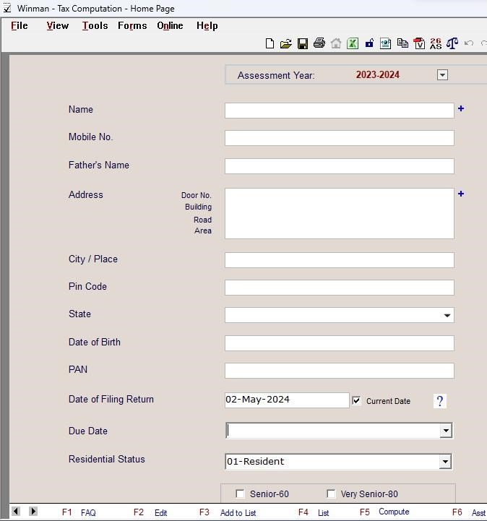

Image 1

Computation is done with the help of a software caller Winman CA ERP. From the above Image we can see a list of fields where the general details of the assessee should be entered.

From the Image 1 by clicking the plus symbol at the right side of the name field a dropdown box will appear as shown in Image 1.1

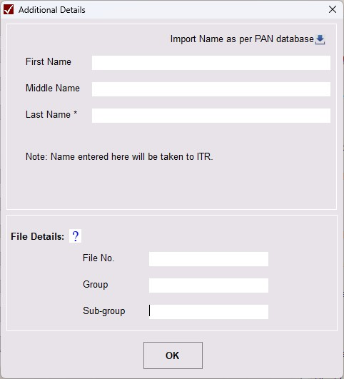

Image 1.1

In the above image name of the assessee should be entered and supporting document should be provided in the field file details. File details are documents like Aadhaar card, pan card and other documents used to verify the assessee.

In the Image 1 date of filing, due date for filing returns and residential status should be selected from dropdown list. If the assessee is a senior or very senior must tick the box below the residential status,60 or 80.

After providing the details the assessee should select the type of capital gain either short-term or long-term capital gains as well as number of gains like as assessee would have earned capital gains from various capital assets from the heads of income like shown in the image 1.3

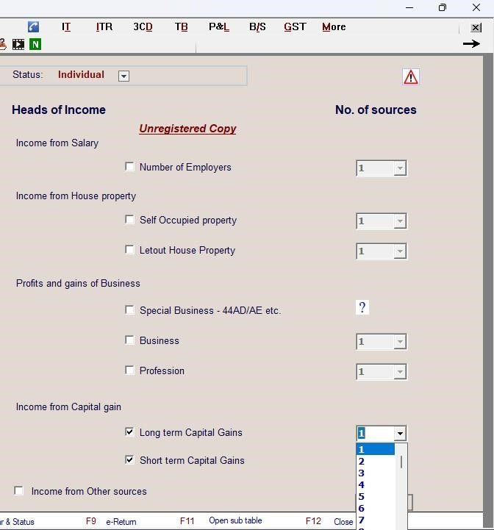

Image 1.3

After entering all the details press F5 or compute from the shortcut tab a new page to compute the capital gains will appear as shown in Image 2.

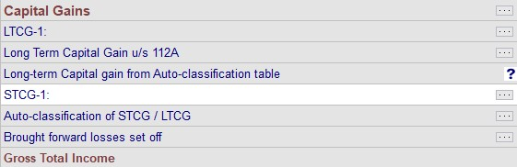

Image 2

By clicking on the symbol  corresponding to LTCG-1 shown in the image 2 a sub table will appear as shown in Image 2.1 where the type of capital asset is sold is selected and further details of the sale should be provided to compute capital gain.

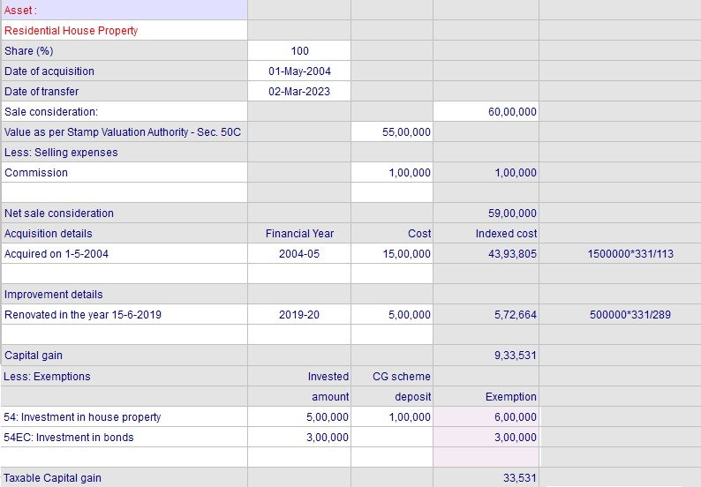

Image 2.1

Above image 2.1 shows the capital gains earned from the sale of a residential house. As pe the section 54 of the IT act 1961 the amount reinvested in the similar asset and amount deposited in capital gain account scheme is fully exempt from tax and other exemption available for this type of asset is section 54EC investment in bonds.

Here acquisition and improvement cost are taken as indexed cost as the asset sold is a long-term capital asset and calculation is shown in the last column in the image 2.1.

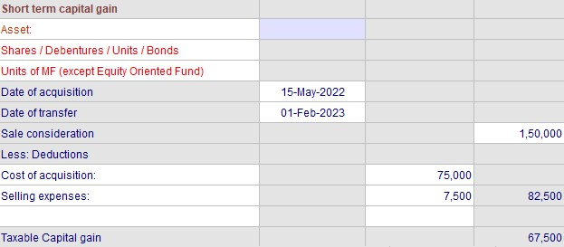

Image 3

The above Image 3 represents the gains earned from the sale of shares. Indexation of cost is not applicable in case of short-term capital gains.

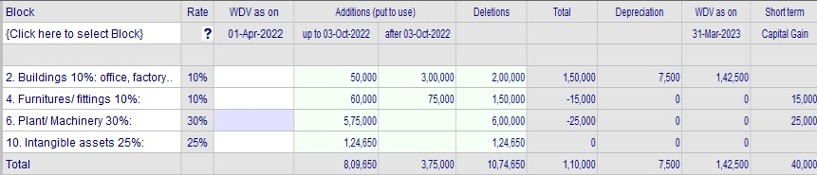

Image 3.1

The above Image 3.1 represents the depreciation as per IT Act from the business in which the short-term capital gain is auto recorded in STCG-1 as shown below in Image 3.2. Even though the block of assets are non-current assets, as per section 50 transfer of depreciable assets it is considered as short-term capital gains.

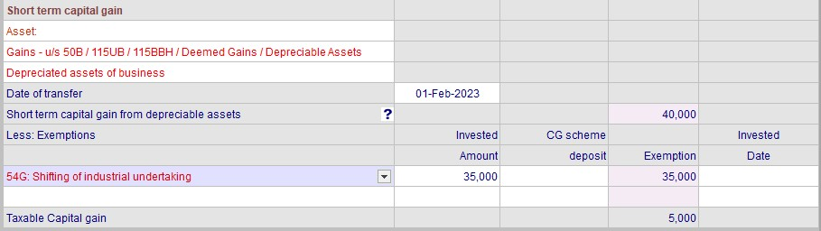

Image 3.2

|  |
| --- |
| **CHAPTER 4**  **LEARNING OUTCOMES** |

This chapter provides a detailed insight of learning outcomes of the internship.

## 4.1 Learning outcomes of the internship

* **Section 54 - Sale of House Property on Purchase of Another House Property:**

Applicable to the assessee individual or HUF. Asset transferred must be a Residential house property and should be a Long-term capital gain. Purchase of new asset for availing exemption should be a Residential house property if Capital gains is less than or equal to 2 crores, two residential houses can be purchased.

Time limit for investment in new asset is within 12 months before or within 24 months after the transfer of asset in case of construction within 36 months from the date of transfer.

Exemption limit is the amount of long-term capital gain or cost of new asset and amount deposited in capital gain account scheme, whichever is lesser.

* S**ection 54B - Transfer of Land Used for Agricultural Purposes:** Applicable to the assessee individual or HUF. Asset transferred should be a land used for agricultural purpose. It can be both short-term and long-term capital gain. Purchase of new asset should be an agricultural land in India. Time limit for new investment in the new agricultural land is within 24 months from the date of transfer.

Exemption limit is the amount of long-term capital gain, or the amount invested in new asset and capital gain account scheme whichever is lesser.

* **Section 54D- Compulsory acquisition of land and buildings used in an industrial undertaking:**

Applicable to any assessee. Asset transferred must be land or building forming a part of an industrial undertaking used for 24months from the date of transfer. It can be both short-term and long-term capital gain. Purchase of new asset must be a land or building for the purpose of re-establishing the industrial undertaking.

Time limit for investment in new asset is within 36 months from the date of transfer.

Exemption limit is the amount of long-term capital gain, or the amount invested in new asset and capital gain account scheme whichever is lesser.

* **Section 54EC - Profits from Sale of Long-Term Capital Asset:** Applicable to any assessee. Asset transferred must be land or building. The purchase of new asset must be specified bonds notified by central government like National Highways Authority of India (NHAI), Rural Electrification Corporation Limited (RECL) bonds and any other notified bonds redeemable after 5 years.

Time Limit for investment in new asset is 6 months from the date of transfer.

The amount of capital gain exemption is limited to Rs. 50 lakhs.

* **Section 54EE - Investment in units of a specified fund:**

Applicable to any assessee. The asset transferred must be a long-term capital asset. New asset purchased must be long-term specified bonds refers to government-notified bonds and securities, such as those issued by the Rural Electrification Corporation (REC) and National Highways Authority of India (NHAI).

Time Limit for investment in new asset is 6 months from the date of transfer.

The amount of capital gain exemption is limited to Rs. 50 lakhs.

* **Section 54F - Capital Gains on Sale of Non-Residential Asset:**

Applicable to the assessee individual or HUF. The asset transferred must be a long-term capital asset other than a residential house. The purchase of new asset should be a residential house property.

Time limit for investment in new asset is within 12 months before or within 24 months after the transfer of asset in case of construction within 36 months from the date of transfer.

Exemption amount is cost of new asset*capital gain/net consideration (maximum up to capital gain)

* To computing capital gains and other heads of income with the help of Winman CA ERP.
* To perform audit and preparation of balance sheet. It is done with the help of a software called tally ERP 9.
* To recording purchase, sales voucher and to create ledger to enter details of the purchaser and seller of a company.
* To file ITR. A basic knowledge of ITR 1,2,3 who is eligible to file under which ITR form.
* To understand about tax rate on long-term and short-term capital asset. Holding period of an asset to be considered as short- term capital or long-term capital asset.
* The internship was useful to experience a work culture and gained some knowledge about a professional workplace.

## 4.2 Findings

* Capital gains have various exemptions and its limits that helps an assessee to reduce tax liability if the specific conditions are followed as stated in those sections of applicable exemptions.
* Indexation of cost helps to reduce tax liability by lowering the long-term capital gain.
* Winman CA ERP helps to compute capital gains accurately.
* Capital gain account scheme helps an assessee to save tax on gains if the gains are high even after reinvesting in similar asset.
* Short-term capital gains do not have the option of Indexation.

## 4.3 Conclusion

Computation of capital gains is complex when an assessee has invested in various assets after the transfer of an asset as each asset has their set of exemptions, limits, and conditions to satisfy to avail those exemptions. The treatment of short-term and long-term has their own advantages and disadvantages.

There are various capital asset of long-term and short-term each of them has their own set of features in respect of computing capital gains and exemptions available to those assets.

|  |
| --- |
| **BIBLIOGRAPHY** |

**Book:**

Direct taxes ready reckoner by Vinod k. Singhania **Web link:** <https://www.investopedia.com/terms/c/capital_gains_tax.asp><https://groww.in/p/capital-gains-tax><https://www.policybazaar.com/income-tax/capital-gains-tax-in-india/><https://tax2win.in/guide/capital-gain-tax-in-india-ltcg-stcg><https://cleartax.in/s/capital-gains-income>

45

**ANNEXURE**